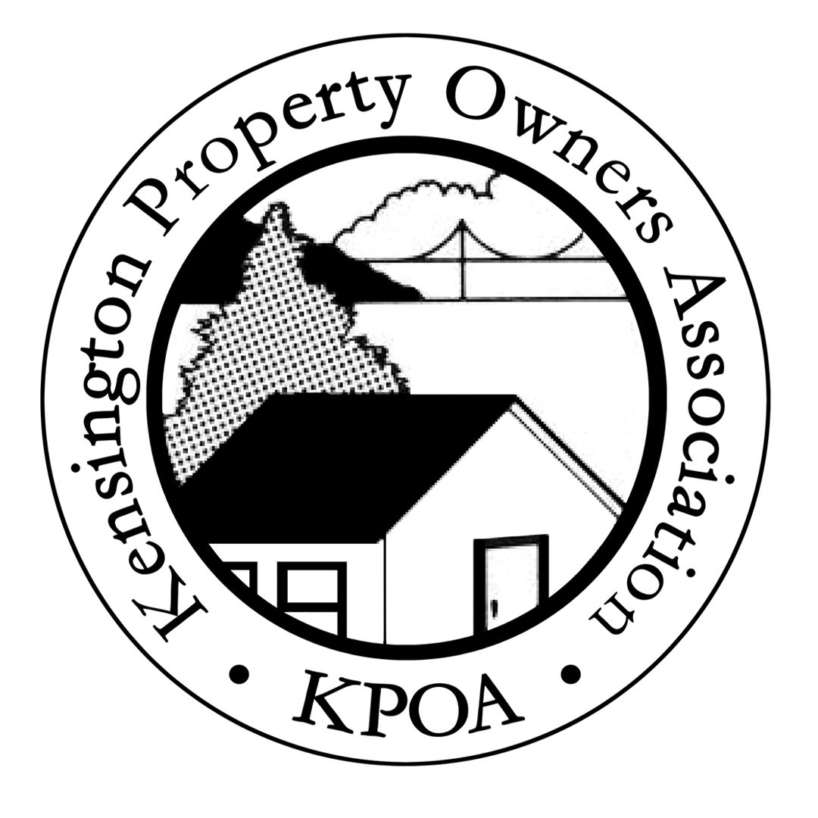

Kensington Property Owners Association

Notice of Annual Meeting

Saturday June 25, 2005 at 10:00 am

The Kensington Community Center
Kensington Park Rd.

Agenda

Ratification of KPOA Officers

- Low Scores for El Cerrito High School – Howard Cohen PhD, Regional Superintendent, Contra Costa Unified School District

Rats in Kensington? - Fred Wall of the Contra Costa Mosquito and Vector Control District

Wildcat Canyon/Tilden Park Wildland Fire Prevention - a representative from the East Bay Regional Park District Fire Division

Kensington Fire Protection District/Department Representative

Contra Costa County Temporary Events Ordinance, status report on Zoning Ordinance Implementation and other County matters Supervisor John Gioia

*The annual meeting is open to all Kensington Property Owners and Residents.
Kensington’s growing rodent population

Although Kensington is not the kind of place one would associate with the problems of urban blight, a recent visit by a commercial pest control service confirmed that business was booming here. The nascent rodent population is quickly breeding its way into becoming one big city problem that won’t get resolved without property owners, taking corrective measures to eliminate habitat and attractions for these very destructive and disease spreading pests. At our Annual Meeting, Fred Walls of the Vector Control District will discuss the secret life of rats, the extent of the local problem and how to better manage and eliminate rats from the neighborhood.

Low Scores at El Cerrito High Could Prompt State Take-over

Schools are one of the most important assets to a community, so it is a great concern to parents of school age children as well as homeowners to learn that continuing low test scores at El Cerrito High could lead to a possible State take-over (required by Federal law). KPOA has invited the WCCU School District to discuss the current situation regarding the schools which serve Kensington, to inform property owners about the future of the High School and how the District is addressing the low achieving school. Dr. Howard Cohen will address us and answer questions regarding what the low scores portend for the future of the school, and the measures the District is taking to turn around the low performance.

Wet Winter = High Fire Risk from Park Vegetation Growth

The past winter saw over 37 inches of rain and the wild grasses and plants in our parks have responded. The Fire Division of the East Bay Regional Park District will discuss how they plan to respond to exceptional vegetation growth in the Tilden and Wildcat Park area and practice fire prevention later this summer.

Proposed Countywide Temporary Events Ordinance

Community input is needed on the Contra Costa County Community Development Department draft Temporary Events Ordinance which establishes parameters for holding public events in residential and other non-commercial zoning districts, including Kensington. The ordinance is the outgrowth of the County’s position that they may not have the ability to ban or limit events, such as concerts in residential zoning districts under existing zoning laws. The County has drafted the ordinance in order to develop regulations that they believe are within the framework of current state laws, and that would allow the County to regulate the conduct of events including the number of attendees, noise, number of occurrences, etc. As most of the Kensington Community is aware, the ordinance could provide administrative procedures to allow continuation of concert productions on Coventry Road.

Join the Directors of KPOA

The KPOA Board of Directors is dedicated to informing the membership of issues concerning all property owners. We hope that you will consider becoming an active member for the benefit of your community. The Board meets quarterly to discuss and review important issues regarding Kensington and our properties. If you have time to participate in one of our projects and would like to get more information, please call Gail Feldman, President 559-8232.

MEMBERSHIP RENEWAL 2005
Please mail to KPOA c/o 299 Arlington Ave. Kensington, CA 94708
Name_____________________
Address_____________________
We encourage the entire community to become members by sending the annual membership fee of $5.

