Kensington Library presents

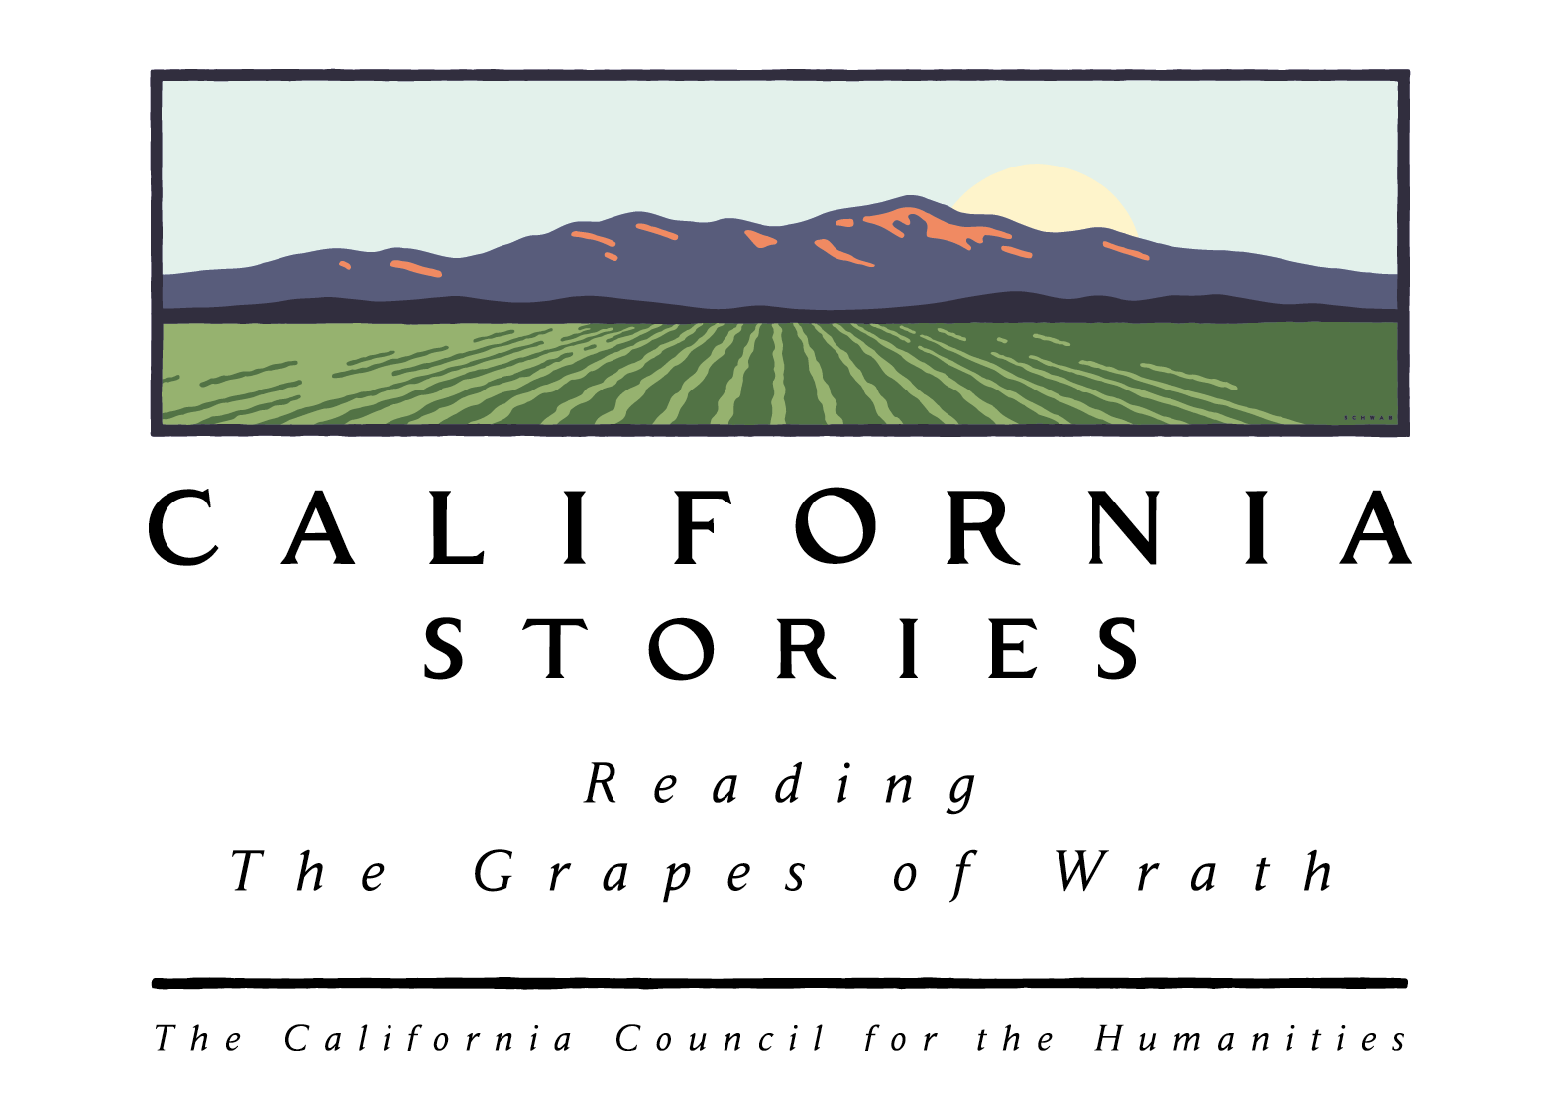

Monday Oct. 7 7 pm

“The faces of Steinbeck’s The Grapes of Wrath”
Jan Goggans is a scholar of Dorothea Lange’s work and has wide experience writing and lecturing on oral history, agricultural literature and photography. Jan Goggans presents a 45 minutes commentary with slides of work of Dorothea Lange. The slide presentation show Lange’s particular interest in the tension between women’s migrant lives and their attempts to set up housekeeping in the West.

Moderated Book Discussion Groups on the Grapes of Wrath
Many copies available to lend!

Monday Oct. 14 7 pm Monday Oct. 21 7pm Monday Oct. 28 7pm

Come read with us! Talk with us!
Kensington Library, 61 Arlington Blvd,
Open Mondays 12-8pm, Tuesdays 12-8pm Wed. closed, Thursday 10-6, Fri 1-5 and Saturday 10-5pm. 510-524-3043

All programs sponsored by the California Council for the Humanities, in partnership with the California Center for the Book and the California State Library and supported in part by the U.S. Institute of Museum and Library Services and Technology Act, administered in California by the State Librarian and by Penguin Books. Local support from the Friends of the Kensington Library.
Recommended website: http://lii.org/TGOW A digital companion to the Grapes of Wrath

